PCI Foundation is the educational entity that supports the Precast/Prestressed Concrete Industry
200 West Adams Street, Suite 2100, Chicago, IL 60606

NEWS RELEASE
Mississippi State University, School of Architecture, Awarded $100,000
PCI Foundation Grants $100,000 to MSU’s School of Architecture,
For 4-year studio precast program

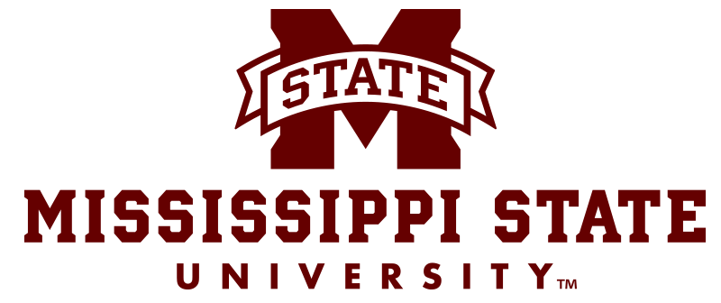
CHICAGO, April 28, 2020 --- Each year the PCI Foundation awards curriculum development grants to universities who submit applications and pass a rigorous review process for acceptance. The School of Architecture at Mississippi State University (MSU) is one of this year’s grantees. MSU has the only school of architecture in Mississippi.
“The PCI Foundation’s mission is to put precast concrete in the classroom so future architects, engineers and construction managers are aware of the possibilities of precast concrete and its myriad uses,” Marty McIntyre, Executive Director of the Chicago-based PCI Foundation. “Key components to each of the grants we award include industry partnership, new precast curriculum and innovative experiential learning.”
“In 2020, we have had a record number of schools apply and are proud to announce that Mississippi State University has been awarded funds for a four-year studio incorporating education about the uses of precast and prestressed concrete.”
Name of University: Mississippi State University, College of Architecture, Art + Design. A collaboration between the School of Architecture and Building Construction Science Program.
Location: 240 Giles Hall, 899 Collegeview Street, Mississippi State, MS 39762
Amount granted: $100,000 over a 4-year period
Timing: January of 2020 – through December of 2023
Academic leader: Alexis Gregory, AIA, Associate Professor in School of Architecture
Perceived Impact: This funding will impact MSU’s Collaborative Studios which were created to address tectonic issues and to teach the students in both architecture and construction how to work together to better prepare them for careers in which their fields regularly collaborate. Further, it will also create lasting relationships between the university, industry partners, and the professional architecture field.
Precast Industry Partners: Jackson Precast, based in Jackson, MS and Tindall Corporation whose Mississippi Division is located in Moss Point, MS.

more

page 2 of 2
Quote from Professor Alexis Gregory, AIA (photo at left)
We will be utilizing this opportunity to begin a relationship with the Department of Civil and Environmental Engineering, and to involve the professional architecture community through workshops, presentations, and lectures, as well as invitations to review the student work. Since we are the only architecture program in Mississippi, this will also help to engage and educate the architectural profession in the state.

ABOUT THE PCI FOUNDATION - Since 2001, the PCI Foundation has been the educational entity that supports the Precast/Prestressed Concrete industry. The mission of the PCI Foundation is to foster educational initiatives focused on innovative approaches to the integrated and sustainable use of precast concrete design, fabrication, and construction. It is a charitable 501(c) 3 corporation, based in Chicago, which supports the inclusion of precast concrete programs at accredited colleges and universities. To learn more, visit the PCI Foundation website at www.PCI-Foundation.org.
###

Media contact: Marty McIntyre, PCI Foundation
martymci@pci-foundation.or or (708) 386-3715
Laura Bennett, Bennett & Company, laura@bennettandco.com

