PCI Foundation is the educational entity that supports the Precast/Prestressed Concrete Industry
200 West Adams Street, Suite 2100, Chicago, IL 60606

NEWS RELEASE
RESEARCH INTO DAPPED ENDS IN NEW GENERATION ULTRA-HIGH PERFORMANCE CONCRETE MEMBERS WINS ALAN MATTOCK GRADUATE SCHOLARSHIP
North Carolina State University PhD Candidate Mohammad Qambar
Awarded 2021 Alan Mattock Graduate Scholarship from PCI Foundation

CHICAGO, May 3, 2021 --- The PCI Foundation has awarded the $4,000 2021 Alan Mattock Graduate Scholarship to Mohammad Qambar, a PhD candidate at North Carolina State University (NCSU). Qambar is a graduate student in the Department of Civil, Construction, and Environmental Engineering, Constructed Facilities Laboratory in Raleigh, NC. Announcement of this award will be held at the PCI Convention in New Orleans, LA on May 20, 2021.
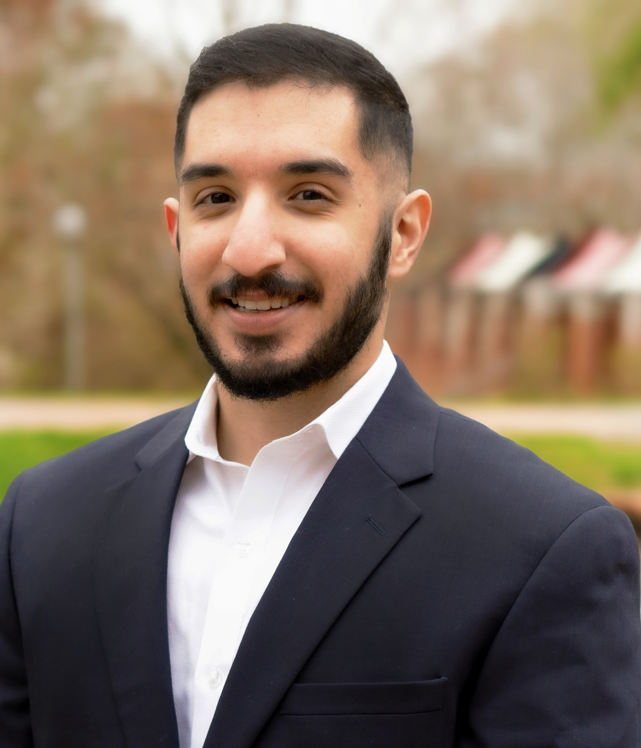
“Implementing Dapped Ends in Very Thin UHPC Stems” is the title of the research Qambar and his advisors will pursue to understand how traditional dapped end members can be adapted to Ultra-High Performance Concrete (UHPC). His co-advising professors at NCSU are Gregory Lucier, PhD, Research Associate Professor and Giorgio Proestos, PhD, Assistant Professor.
I am overjoyed and incredibly honored to have received this fellowship and scholarship from PCI and the PCI Foundation. Implementing dapped ends in UHPC members combines the challenges of designing an end condition that involves a complex distribution of stress with an exciting material that has made previously impractical designs a reality. It is my hope to become a small part of the long legacy of excellent PCI dapped end researchers by helping to further investigate a concept that is crucial to producers and designers alike.

I am grateful to the industry producers, my advisors, PCI, and the PCI Foundation for making this incredible opportunity possible, and I am excited for what lies ahead!

Mohammad Qambar, (photo) recipient of the 2021 Alan Mattock Graduate Scholarship, from the PCI Foundation.

Qambar’s research will focus on the complex distribution of stresses and compatibility conditions that arise at dapped ends, necessitating a careful proportioning of reinforcing steel to ensure adequate performance and serviceability, particularly in thin-stemmed members.

more
Page 2 of 2
Qambar also received a 2021 PCI Daniel P. Jenny Research Fellowship. Based on his outstanding application, the PCI Research and Development Committee recommended him for the Alan Mattock Scholarship.
ABOUT DR. ALAN MATTOCK - Alan Mattock was a professor at the University of Washington and was a driving force in the precast/prestressed concrete industry, particularly in the area of research. He was an active participant in the PCI Research and Development committee. Mattock retired in 1990 after a career filled with awards, high-profile committee work, and many published papers. He passed away on June 6, 2014. After his death, some of his contemporaries and others who worked with him on PCI projects over the years felt that a memorial scholarship that recognized scholars interested in research would be appropriate in his name.
ABOUT THE PCI FOUNDATION - Since 2001, the PCI Foundation has been the educational entity that supports the Precast/Prestressed Concrete industry. The mission of the PCI Foundation is to foster educational initiatives focused on innovative approaches to the integrated and sustainable use of precast concrete design, fabrication, and construction. It is a charitable 501(c) 3 corporation, based in Chicago, which supports the inclusion of precast concrete programs at accredited colleges and universities. To learn more, visit the PCI Foundation website at www.PCI-Foundation.org.
###

Media contact: Marty McIntyre, PCI Foundation
martymci@pci-foundation.or or (708) 386-3715

