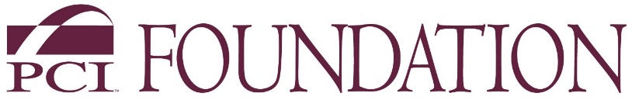
PCI Foundation is the educational entity that supports the Precast/Prestressed Concrete Industry
200 West Adams Street, Suite 2100, Chicago, IL 60606

NEWS RELEASE
McNeese State University, College of Science, Engineering & Mathematics Awarded $100,000
PCI Foundation Grants $100,000 to McNeese State University for a 4-year studio focused on precast and prestressed concrete education

CHICAGO, February 10, 2021 --- Each year the PCI Foundation awards curriculum development grants to universities who submit applications and pass a rigorous review process for acceptance. McNeese State University (MSU) is one of this year’s grantees. MSU is located in Lake Charles, LA and is a public university.
“The PCI Foundation’s mission is to put precast concrete in the classroom so future architects, engineers and construction managers are aware of the possibilities of precast concrete and its myriad uses,” said Marty McIntyre, Executive Director of the Chicago-based PCI Foundation. “Key components to each of the grants we award include industry partnership, new precast curriculum and innovative experiential learning.”
“For 2021, we had a record number of schools apply and are proud to announce McNeese State University has been awarded funds for a four-year studio incorporating education about the uses of precast and prestressed concrete.”
Name of University: McNeese State University, College of Science, Engineering & Mathematics
Location: Drew Hall, Lake Charles, LA
Amount granted: $100,000 over a 4-year period
Timing: 2021 through 2024
Precast Industry Partners: Tindall Corporation and Lake Charles, LA based Alfred Miller Companies and Dunham Price Group.

more

page 2 of 2

Quote from Ahmed Abdel-Mohti, McNeese State University, Associate Professor, Civil Engineering (photo)
“This grant is a good fit for our program due to the state’s Petro Chemical industry as well as the presence of precast and prestressed concrete contractors in the local area.
This 4-year studio will give students a better idea of the importance of precast concrete in the real world. We will offer a new course and incorporate the benefits and impact of precast and prestressed concrete into design and construction.
ABOUT THE PCI FOUNDATION - Since 2001, the PCI Foundation has been the educational entity that supports the Precast/Prestressed Concrete industry. The mission of the PCI Foundation is to foster educational initiatives focused on innovative approaches to the integrated and sustainable use of precast concrete design, fabrication, and construction. It is a charitable 501(c) 3 corporation, based in Chicago, which supports the inclusion of precast concrete programs at accredited colleges and universities. To learn more, visit the PCI Foundation website at www.PCI-Foundation.org.

###

Media contacts: Marty McIntyre, PCI Foundation
martymci@pci-foundation.or or (708) 386-3715
Laura Bennett, Bennett & Company, laura@bennettandco.com

