2019 Annual PCIF Barbecue Competition Has A Winner
PCI Foundation is the educational entity that supports
the

Precast/Prestressed Concrete Industry

1770 N. Park Street, #103, Naperville, IL 60563

NEWS RELEASE

Gate Precast Kissimmee, Florida Raises More Than $17,000 To Support the PCI Foundation’s Mission To Educate About Precast Concrete

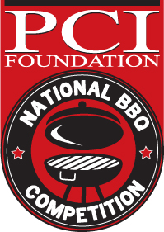
CHICAGO, January 27, 2020 --- The results are in and Gate Precast Kissimmee, Florida is the winner of the 2019 National Barbecue Competition sponsored by the PCI Foundation.
This annual competition is a fundraiser for the educational mission of the Chicago-based PCI Foundation working with top universities across the United States to teach students in architecture, engineering and construction management about precast concrete.
The national competition is open to any precast concrete industry producer or vendor and in 2019 there were entries from across the country.
The Gate Precast Kissimmee plant went all out with custom t-shirts that set the tone with this message “A pig, a chicken & a cow walk into a Bar-B-Q. The end.”
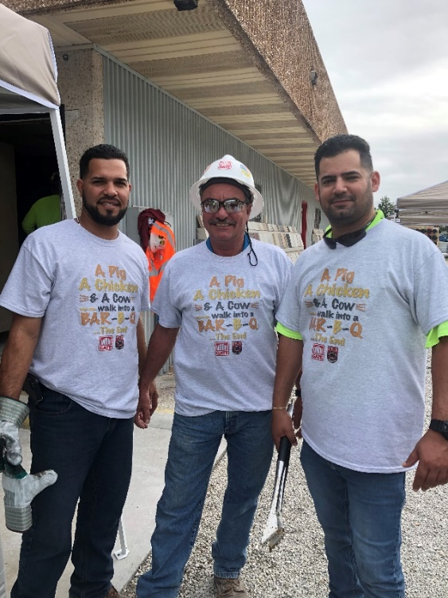
More than 120 pounds of meat was served to 160 employees in Kissimmee (near Orlando) who enjoyed tug of war, punch hole and football toss games. Raffles were also held for vacation time and a television. One hundred percent of the employees attended the event held in November.
At other competitions unique menu items were offered like Cajun Grits, employee-made sausage and farm raised chickens raised by a loader operator. Another competitor increased their “fun-raising” amount with “too many to count” raffle items from vendors, collected all year by the team in Purchasing,
This popular event will be expanded in 2020 with more categories and events are now able to be held any time of the year.
ABOUT THE PCI FOUNDATION - Since 2001, the PCI Foundation has been the educational entity that supports the Precast/Prestressed Concrete industry. The mission of the PCI Foundation is to foster educational and research initiatives focused on innovative approaches to the integrated and sustainable use of precast concrete design, fabrication, and construction. It is a charitable 501(c) 3 corporation, based in Chicago, which supports the inclusion of precast concrete programs at accredited colleges and universities. To learn more, visit the PCI Foundation website at www.PCI-Foundation.org.
###
Media contact: Laura Phillips Bennett, laurabennett@PCI-Foundation.org, cell: 407-701-5454

